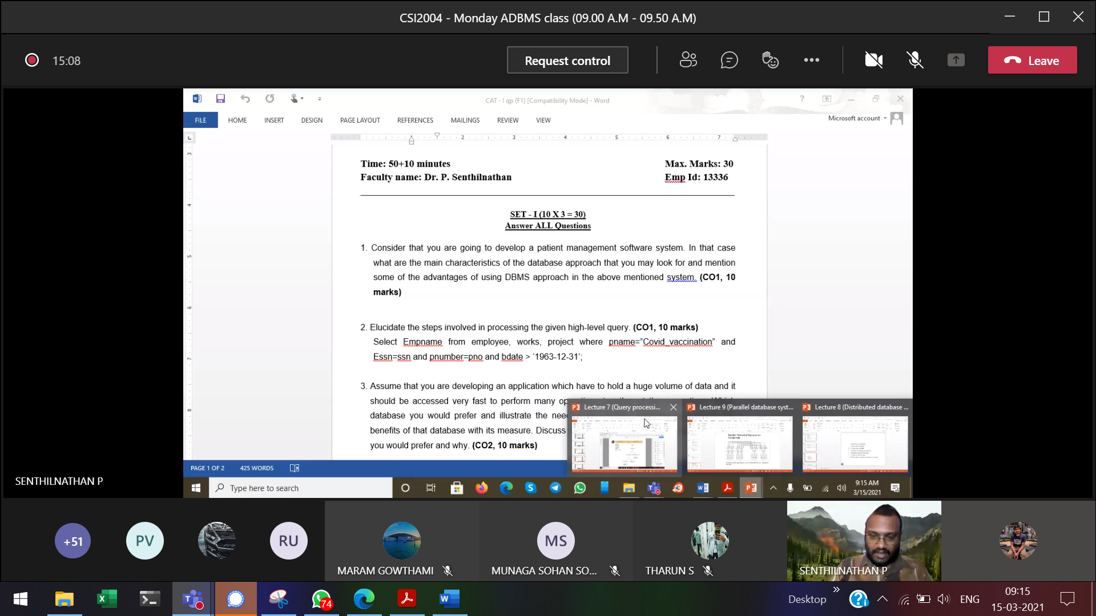

Set-1

1) Consider that you are going to develop a patient management software system. In that case what are the main characteristics of the database approach that you may look for and mention some of the advantages of using DBMS approach in the above mentioned system. (10 marks)

2) Assume that you are developing an application which have to hold a huge volume of data and it should be accessed very fast to perform many operations together at the same time. Which database you would prefer and illustrate the need of the chosen database and specify the benefits of that database with its measure. Discuss which architectures of the chosen database you would prefer and why. (10 marks)

3) Elucidate the steps involved in processing the given high-level query. (10 marks)  
Select Empname from employee, works, project where pname=”Covid_vaccination” and Essn=ssn and pnumber=pno and bdate > ‘1963-12-31’;

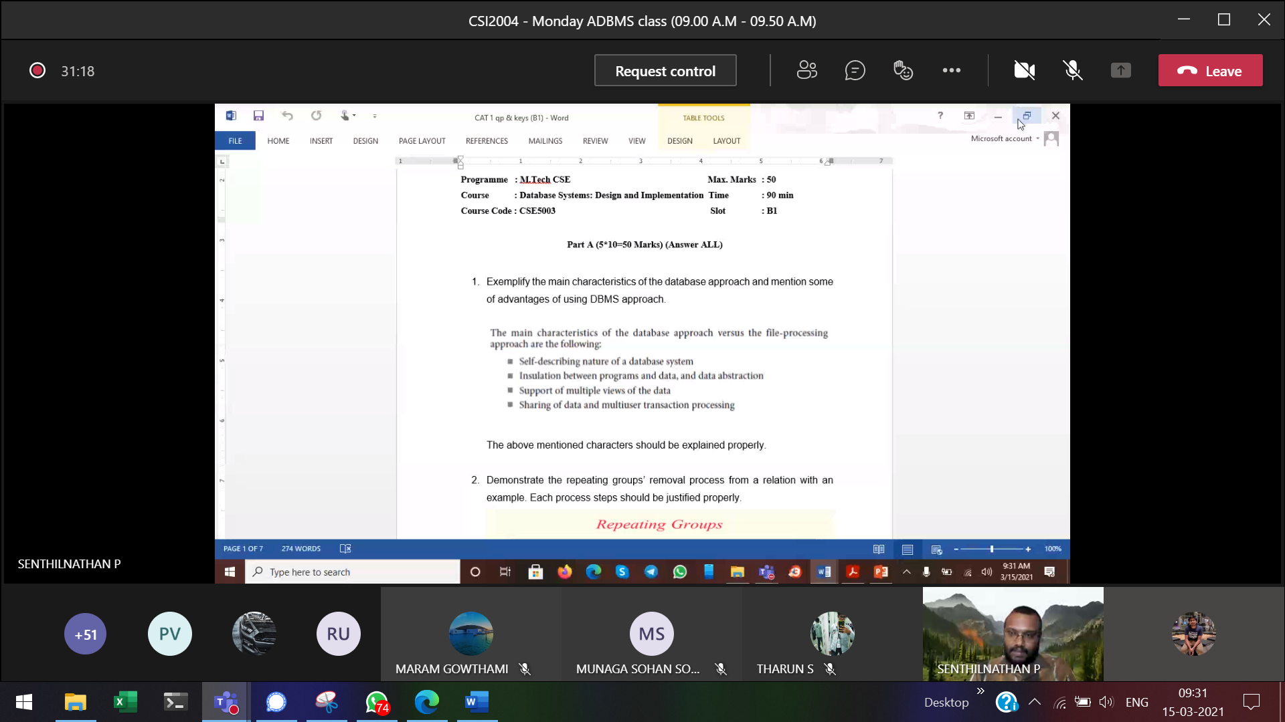

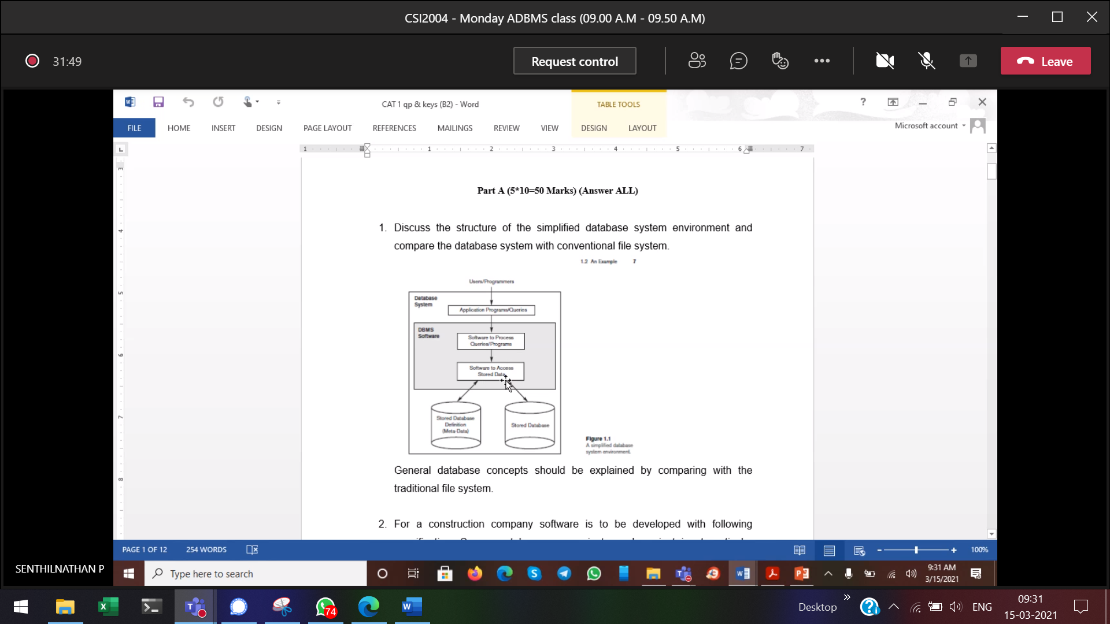

Set-2

1) Assume that you are developing an application which have to hold a huge volume of data and it should be accessed very fast to perform many operations together at the same time.  
Which database you would prefer and illustrate the need of the chosen database and specify the benefits of that database with its measure. Discuss which architectures of the chosen database you would prefer and why.

2) For a construction company software is to be developed with following specifications-Company takes many projects each project is at a particular location. Each project is supervised by project manager assigned by CEO of the company. Record related to start of project, its completion is to be maintained. Under each project manager there is a team of people of different categories like designer, plumber, electrician, architect, labour etc. Each project is marketed by team of marketing executives. Draw the enhanced ER diagram for the above mentioned project and justify your answer with proper comments. (10 marks)

3) Consider that you are going to develop an air e-ticketing software system. In that case how you will have a simplified database system environment and specify the activities involved in the system with the perspective of data manipulation. (10 marks)

Assume that you are developing an application that should have the location independency towards the data in which it is dealing and also all the transactions should be transparent even though it is done between different sites. Which database you would prefer and illustrate the need of the chosen database and specify how the storage of data will be in that database. Discuss which architectures of the chosen database you would prefer and why.